APS 1016 Financial Management for Engineers
Main Project
Professor Babu Gajaria
University of Toronto
Date: July 24th, 2024

Yuyang Zhang 1005051667
Cassie(Zi) Wang 1004959324
Jiaying Zheng 1005793232
Yuchen Zhang 1005693019



Table of Contents

- Executive Summary Page 2
- Industry Analysis Page 2
2.1 Barriers to Entry Page 2
2.2 Power of Suppliers Page 3
2.3 Power of Buyers Page 3
2.4 Threat of Substitutes Page 3
2.5 Industry Rivalry Page 3
- Financial Analysis Page 4
3.1 Ratio Analysis Page 4
3.2 Common Size Analysis Page 5
3.3 Pro Forma Income Statement Page 6
3.4 Pro Forma Balance Sheet Page 6
- Forecasting Stock Value Page 7
4.1 Historical Average Calculation Page 7
4.2 Forecasting Stock Price Page 9
- WACC Page 10
- Conclusion Page 12
- Recommendation Page 12
- Reference Page 13

1 - Executive Summary
This report aims to conduct a comprehensive equity valuation of two public companies in the Canadian retail industry - Loblaw and Walmart. We analyze the financial status and future prospects of these companies through fundamental analysis methods. The retail industry in Canada is highly competitive, with major players such as Loblaw and Walmart competing for market share. The industry is characterized by moderate barriers to entry, a diverse range of suppliers, strong buyers due to consumer demand, an abundance of substitute products, and intense competition among existing competitors.
This report uses several analytical methods to evaluate the financial health of Loblaw and Walmart and predict their future performance. The main analyses include Industry Analysis: Using Porter's Five Forces Framework, we will evaluate the competitive environment and its impact on the profitability of the two companies. Financial Ratio Analysis: ratio analysis is a financial analysis computation tool which is used to evaluate a company's performance, financial health, and operational efficiency by computing and interpreting various financial ratios derived from its financial statements. In this part, we will concentrate on the ratio analysis of Loblaws and Walmart based on the current ratio, debt/equity ratio, inventory turnover, profit margin, return on asset and equity. Common-size analysis: is a method to express each financial factor in financial statements as a percentage, and it enables us to easily compare across different periods and identify trends and disparities in financial performance. To conduct a common-size analysis, we utilize common-size financial statements to highlight changes in the relative significance of each item. Forecast Financial Statements: We will forecast the financial statements, including the balance sheet and income statement, for the next three years to predict future financial performance. Stock Value Forecast: Using models such as the dividend growth model, price-to-earnings multiple, and discounted cash flow analysis, we will estimate the future stock price of the two companies.
2 - Industry Analysis
The Canadian retail industry is a dynamic and competitive market characterized by several key factors that influence the profitability and sustainability of businesses within this sector. To evaluate the competitive environment of the retail industry, we will use Porter’s Five Forces framework.
2.1 - Barriers to Entry
The barriers to entry in the Canadian retail industry are moderate. Significant capital investment is required to establish a strong market presence, including costs related to store locations, inventory, and marketing. Additionally, established brands like Loblaw and Walmart have strong brand loyalty and economies of scale, making it difficult for new entrants to compete on price and variety. However the Canadian retail industry, on the other hand, does not require as much trained human resources and high-cost development infrastructure as other industries.
2.2 - Power of Suppliers
The power of suppliers in the retail industry is relatively low. Retailers like Loblaw and Walmart have numerous suppliers to choose from, which reduces the dependency on any single supplier. Large retailers can also negotiate better terms due to their high purchase volumes.But, suppliers of unique or high-demand products may have more bargaining power.
2.3 - Power of Buyers
The power of buyers in the retail industry is high due to the availability of numerous retail options and low switching costs. Customers can easily compare prices and products across different retailers, leading to intense competition among retailers to attract and retain customers. Both Loblaw and Walmart invest heavily in customer loyalty programs and competitive pricing strategies to maintain their customer base. Because buyers are very price sensitive, they can quickly choose a retail merchant with a better price, so the bargaining power of customers is high.
2.4 - Threat of Substitutes
The threat of substitutes in the retail industry is moderate. Customers have access to a variety of substitute products and services, including online shopping platforms, specialty stores, and wholesale clubs. The growing trend of e-commerce, in particular, poses a significant threat to traditional brick-and-mortar retailers. To mitigate this threat, both Loblaw and Walmart have developed robust online shopping platforms and omnichannel strategies. Since Loblaw and Walmart are making adjustments to their strategy, the threat of substitutes is moderate.
2.5 - Industry Rivalry
The level of rivalry in the Canadian retail industry is high. With many established players like Loblaw and Walmart, as well as smaller regional retailers, the competition for market share is intense. Price wars, frequent promotions, and extensive advertising are common strategies used by retailers to gain a competitive edge. The high level of rivalry pressures companies to continuously innovate and improve their offerings to attract customers.
3 - Financial Analysis
3.1- Ratio Analysis
Based on the ratios table, Loblaws and Walmart represent distinct financial trends compared to industry averages. Loblaws maintains stable liquidity with a current ratio of 1.37 in 2021, and slightly decreased to 1.25 in 2023, which remains within the common industry range of 1.2 to 2.0. Walmart shows a consistent current ratio of 1.53 in 2021 and increased to 1.60 in 2022 before returning to 1.53 in 2023. Both companies have high debt/equity ratios, with Loblaws at 2.15 in 2021, raised to 2.39 in 2023, and Walmart at 2.04 in 2021 fluctuated to 2.08 in 2023. These financial ratios suggest heavy reliance on debt financing, which could be concerned if interest rates rise or profitability declines. Walmart focuses on inventory turnover with a ratio of 9.35 in 2021, though it decreased to 8.20 in 2023 but it still indicates efficient inventory management compared to Loblaws, which has a ratio of 7.05 in 2021, and slightly decreased to 6.96 in 2023. Profit margins for Loblaws remain steady, at 3.53% in 2021 and 2023, with a slight climb down to 3.40% in 2022 which reflect stable profitability. In contrast, the profit margins of Walmart represent a declining trend from 2.42% in 2021 to 1.91% in 2023 which indicates potential challenges. Both companies demonstrate strong ROA and ROE with Loblaws is 5.12% in 2021, and slightly increased to 5.39% in 2023, and its ROE is 16.20% in 2021 and raised to 18.32% in 2023, therefore this trend indicates effective use of assets and equity. The ROA of Walmart was 5.35% in 2021 and climbed up at 5.58% in 2022 before dropping to 4.80% in 2023, and its ROE is 16.69% in 2021, declined to 15.23% in 2023.
In the final analysis, Loblaws' stable profitability, strong ROA, and improved ROE represent potential for stock price appreciation, despite its high debt/equity ratio. In contrast, Walmart’s efficient inventory management and historically strong financial ratios are positive indicators, but recent declines in profit margin and ROA may negatively impact investor confidence and future stock prices if not addressed. Both companies are financially healthy, but Walmart needs to resolve its profitability and asset efficiency issues to maintain a positive expectation.
3.2 - Common Size Analysis
The common size analysis of Loblaws and Walmart represents distinct trends in their financial health. Loblaws maintains stable total current assets around 34.5%, while Walmart's decreased from 35.67% in 2021 to 31.11% in 2023 which suggest reduced in liquidity. Both companies increased net receivables and inventory, though Walmart's inventory levels rose more significantly. On the liabilities side, Loblaws' total current liabilities increased from 25.12% to 27.83%, and Walmart’s from 36.69% to 37.91%. Loblaws has a higher dependence on long-term debt which was reflected in its higher total liabilities percentage of around 70%, compared to Walmart’s consistent 65%. Based on the profitability, Loblaws shows a stable gross profit margin which was increased slightly from 31.47% to 31.98%, and maintained a net income of 3.53%. Walmart represents a slight decrease in gross profit margin from 24.83% to 24.14% and a decline in net income from 2.42% to 1.91% that indicate profitability challenges. Both companies maintain stable selling and administrative expenses, with Loblaws at around 25.90% and Walmart at approximately 20.80%. As suggested here, both companies demonstrate stability in operating expenses as a proportion of revenue, but they differ significantly in terms of liquidity and profitability trends. Loblaws shows a stable and slightly enhanced financial position with consistent profitability and a high dependence on long-term debt. However, Walmart faces declining profitability despite maintaining efficient inventory management and a stable asset base. The higher inventory levels and consistent current liabilities indicate Walmart's strategy of maintaining robust stock levels, possibly to cater to a broad customer base. The overall retail market remains competitive, requiring companies to balance liquidity, debt management, and profitability effectively. Loblaws' stable profitability and improving financial metrics suggest it is well-positioned to handle market fluctuations and leverage growth opportunities. On the other hand, Walmart needs to address its declining profitability to maintain investor confidence and sustain its market position.

3.3 - Pro Forma Income Statement
Loblaw's and Walmart's revenue trends share some similarities, driven by factors such as robust retail sales, financial services, and macroeconomic conditions, and have both grown consistently over the past three years. Loblaw's revenue growth is influenced by inflationary pressures, value offerings, and seasonal factors. Walmart's revenue growth is brought by strong food sales, eCommerce growth. For the pro forma income statement, we use an average growth rate of 5.81% for Loblaw's revenue and 4.58% for Walmart's revenue, reflecting historical trends and expected future conditions. Both companies experienced increases in COGS due to higher input costs, inflation, operational expenses, and supply chain costs. We project COGS growth rates of 5.42% for Loblaw and 5.08% for Walmart using the past three-year growth rate for COGS. SG&A expenses increased for both companies due to higher labor costs and operating leverage. We assume this item as a percentage of total sales. Interest expenses rose due to higher debt levels and interest rates, with projections set at 1.31% of total sales for Loblaw and 0.37% for Walmart. The effective tax rates fluctuate, projected at 22.90% of income before tax for Loblaw and 30.81% for Walmart. Accounts receivable improved for both companies; however, trade payables for Loblaw increased due to higher inventory purchases and extended payment terms, while Walmart's trade payables remained stable. Depreciation and amortization expenses rose for both companies due to higher investments in property and equipment, with Loblaw's expenses also driven by leased and IT assets depreciation and accelerated network optimization. We project depreciation growth rates of 12.16% for Loblaw and 7.23% for Walmart. Net income and EPS for Loblaw grew in the past three years, reflecting improved operational performance and share repurchases. In 2023, Loblaw increased its quarterly dividend to $0.446 per share, totaling $550 million, while retaining sufficient free cash flow for future growth and progressively increasing dividend payouts. For Walmart, net income decreased from $13.94 billion in 2022 to $11.29 billion in 2023, with EPS dropping from $4.87 to $4.27. Walmart increased its quarterly dividend to $0.57 per share in 2023.
3.4 - Pro Forma Balance Sheet
To forecast the balance sheet accurately, we considered several factors for both Loblaw and Walmart. For the cash position, we utilized a rolling average of the past three years to smooth out any anomalies and provide a more stable projection. This approach takes into account the recent operational trends and cash flow activities mentioned in the companies' annual reports. In terms of inventories, we applied average inventory turnover rates, which are derived from historical data, to project future inventory levels. This method ensures that the projection aligns with the companies' efficient inventory management practices. For property, plant, and equipment (PPE), we first forecasted the gross PPE by examining historical growth rates and capital expenditure trends. We then projected the corresponding depreciation using historical depreciation rates. The net PPE value was obtained by subtracting the projected depreciation from the gross PPE. This detailed approach ensures that both growth in assets and their wear and tear are accurately represented. When forecasting accounts payable, we used the average accounts payable ratio for the past three years, which reflects the relationship between accounts payable and COGS. This ratio, when multiplied by the forecasted COGS, provides a reliable estimate of future accounts payable. For long-term debt, due to the lack of specific future plans in the annual reports, we used the average long-term debt level from the past three years. This assumption provides a conservative estimate that accounts for the companies' historical borrowing practices without speculating on future changes.
4 - Forecasting Stock Value
We get the historical data of stock prices and the cash flow statement from 2021 to 2023 from Yahoo Finance. We use the year-end adjusted close prices as price per share for the last three years to calculate the historical averages. And we will forecast the stock price based on historical average P/E ratio, and P/CF ratio and the forecasted future earnings and cash flow. And the data is shown in the exhibit.
4.1 - Historical Average Calculation
From the above information, we forecast the stock price based on P/E ratio, and P/CF ratio.
P/E ratio = Price per Share/ EPS; P/CF ratio = Price per Share/ Cash Flow per Share
4.1.1 - Loblaws
From Income Statement and Cash Flow Statement, we get the data of Earnings (Net Income), Operating Cash Flow, Sales (Total Revenue), and the Basic EPS as earnings per share.
The price per share for 2021 is $99.77, for 2022 is $116.86, and for 2023 is $127.04. And EPS for 2021 is 5.49, for 2022 is 5.82 and for 2023 is 6.59.
2021: P/E ratio = 99.77/5.49 = 18.173 2022: P/E ratio = 116.86/5.82 = 20.079
2023: P/E ratio = 127.04/6.59 = 19.278
Average P/E ratio = $\frac{18.173+20.079+19.278}{3}$ = 19.177
Number of Shares = Earnings/ EPS. Therefore the number of shares for 2021 is 341530, for 2022 is 330069, and for 2023 is 318665.
The operating cash flow for 2021 is $4755000, for 2022 is $5654000, and for 2023 is $5595000.
Cash Flow per Share: 2021: 4755000/341530 = 13.92
2022: 5654000/330069 = 17.13 2023: 5595000/318665 = 17.56
P/CF ratio: 2021: P/CF ratio = 99.77/13.92 = 7.17
2022: P/CF ratio = 116.86/17.13 = 6.82 2023: P/CF ratio = 127.04/17.56 = 7.23
Average P/CF ratio = $\frac{7.17+6.82+7.23}{3}$ = 7.07
4.1.2 - Walmart
The price per share for 2021 is $46.26, for 2022 is $46.06, and for 2023 is $52. And EPS for 2021 is 1.59, for 2022 is 1.63, and for 2023 is 1.43.
So the P/E ratio is calculated as follows: 2021: P/E ratio = 46.26/1.59 = 29.09
2022: P/E ratio = 46.06/1.63 = 28.26 2023: P/E ratio = 52/1.43 = 36.36
Average P/E ratio = 31.24
2021: Number of Shares = 13510000/1.59 = 8496855
2022: Number of Shares = 13673000/1.63 = 8388343
2023: Number of Shares = 11680000/1.43 = 8167832
The operating cash flow for 2021 is $36074000, for 2022 is $24181000, and for 2023 is $28841000.
Cash Flow per Share: 2021: 36074000/8496855 = 4.25
2022: 24181000/8388343 = 2.88 2023: 28841000/8167832 = 3.53
P/CF ratio: 2021: P/CF ratio = 46.26/4.25 = 10.90
2022: P/CF ratio = 46.06/2.88 = 15.98 2023: P/CF ratio = 52/3.53 = 14.73
Average P/CF ratio = 13.87
4.2 - Forecasting Stock Price
We will forecast next year’s earnings and cash flow by multiplying next year’s earnings and cash flow by average P/E and P/cash flow multiple to arrive at the forecasted stock price.
From part 3, we have made assumptions for the income before tax and revenue growth rate.
4.2.1 - Loblaws
Forecast next year's earnings and cash flow:
Earnings for 2023: $2,100,000
Growth Rate for Earnings: 4.72%
Projected Earnings for 2024 = 2,100,000 × (1 + 4.72%) = 2,198,120
Operating Cash Flow for 2023: $5,595,000
Growth Rate for Cash Flow: 5.81%
Projected Cash Flow for 2024 = 5,595,000 × (1 + 5.81%) = 5,920,020
Calculate the projected stock price:
Using P/E Ratio:
Projected EPS = 2,198,120 / 318,665 = 6.90
Projected Stock Price (P/E) = Average P/E × Projected EPS = 19.177 × 6.90 = 132.32
Using P/Cash Flow Ratio:
Projected Cash Flow per Share = 5,920,020 / 318,665 = 18.57
Projected Stock Price (P/Cash Flow) = Average P/Cash Flow × Projected Cash Flow per Share = 7.07 × 18.57 = 131.29
4.2.2 - Walmart
Forecast next year's earnings and cash flow:
Assume the growth rates are applied to the most recent year's data.
Earnings for 2023: $11,680,000
Growth Rate for Earnings: 3.24%
Projected Earnings for 2024 = 11,680,000 × (1 + 3.24 / 100) = 12,057,232
Operating Cash Flow for 2023: $28,841,000
Growth Rate for Cash Flow: 4.58%
Projected Cash Flow for 2024 = 28,841,000 × (1 + 4.58 / 100) = 30,157,697
Calculate the projected stock price:
Using P/E Ratio:
Projected EPS = 12,057,232 / 8,167,832 = 1.48
Projected Stock Price (P/E) = Average P/E × Projected EPS = 31.24 × 1.48 = 46.24
Using P/Cash Flow Ratio:
Projected Cash Flow per Share = 30,157,697 / 8,167,832 = 3.69
Projected Stock Price (P/Cash Flow) = Average P/Cash Flow × Projected Cash Flow per Share = 13.87 × 3.69 = 51.20
Based on the historical data and the calculated ratios, Loblaws shows a slightly higher stability in its price forecast, with projected stock prices close in value whether using P/E or P/CF ratios. Walmart, however, exhibits a more significant difference between the two forecasting methods, indicating potential variability in stock performance based on cash flow changes. Overall, both companies are projected to have moderate growth in their stock prices next year, with Loblaws expected to reach around $132 and Walmart between $46 and $51.
5 - WACC
We have found the risk free rate (10-Y treasury bond) from the U.S. Department of the Treasury website.[3] We have found the beta (5Y Monthly) from Yahoo Finance.[1][2] And we have found market rate (average return) from Investopedia.[4]
5.1 - Loblaws
Risk-free Rate(rf): 4.30% (from the Treasury yield data provided)
Market Return(rm): 10.26% (average annualized return since 1957)
β: 0.15
Market value of Equity (Market Cap): $52.09B
Long Term Debt(2023): $6,661,000,000 Current Debt(2023): $2,054,000,000
Total Debt (D) = Long Term Debt + Current Deb = 6,661,000,000 + 2,054,000,000 = 8,715,000,000
Cost of Equity (re): Using the CAPM formula:
re = rf + β × (rm − rf) = 4.30% + 0.15 × (10.26% − 4.30%) = 5.194%
Cost of Debt (rd):
Interest Expense (2023): $825,000,000 Total Debt (D): $8,715,000,000
rd = Interest Expense/ Total Debt = 825000000/8715000000 = 0.0946 = 9.46%
Income Before Tax: $2,901,000,000 Income Tax Expense: $714,000,000
Effective Tax Rate(T) = Income Tax Expense/Income Before Tax = 0.246 = 24.6%
We = E/(D+E) = 0.857 Wd = D/(D+E) = 0.143
WACC = We × re + Wd × rd × (1-T) = 0.857 × 5.194% + 0.143 × 9.46% × (1-24.6%) = 5.47%
5.2 - Walmart
Market Value of Equity (E)/Market Cap: $568.276B
Market Value of Debt (D):
Long Term Debt: $34.649B Current Debt: $4.563B
Total Debt: $34.649B + $4.563B = $39.212B
Risk-free Rate (rf): 4.30% β (5Y Monthly): 0.50 Market Return (rm): 10.26%
Using the CAPM formula:
re = rf + β × (rm − rf) = 4.30% + 0.50 × (10.26% − 4.30%) = 7.28%
Interest Expense (2023): $2.128B Total Debt: $39.212B
Cost of Debt(rd) = Interest Expense/Total Debt = 2,128,000,000/39,212,000,000 = 5.43%
Effective Tax Rate (T):
Income Before Tax (2023): $17.016B Income Tax Expense (2023): $5.724B
Effective Tax Rate (T) = Income Tax Expense/ Income Before Tax = 0.336 = 33.6%
Wd = D/(D+E) = 0.065 We = E/(D+E) = 0.935
WACC = We × re + Wd × rd × (1-T) = 0.935 × 7.28% + 0.065 × 5.43% × (1-33.6%) = 7.04%
Therefore, WACC for Loblaws is 5.47%, and WACC for Walmart is 7.04%.
6 - Conclusion
Our report evaluates Loblaw and Walmart, two key players in the Canadian retail industry. Using Porter's Five Forces, we identify the industry as highly competitive, with moderate entry barriers, low supplier power, high buyer power, moderate threat of substitutes, and intense rivalry. Our financial analysis shows Loblaw’s stable profitability and strong asset efficiency, despite high debt levels. Walmart shows efficient inventory management but faced declining profitability, which could impact its stock price. Pro forma statements revealed consistent growth for both companies. Loblaw’s financial stability positions it well for market fluctuations, while Walmart needs to address its declining profitability to maintain investor confidence. Stock value forecasts suggest Loblaw's price is likely to grow, which shows its strong financial health. Walmart’s stock price has potential but requires improved profitability to meet expectations. In summary, Loblaw shows stronger financial health and growth prospects, while Walmart must resolve profitability issues to sustain its market position.
7 - Recommendations
Based on the comprehensive analysis of Loblaw and Walmart in our reports, we can provide insightful investment recommendations. Given Loblaw's consistent financial performance, strong market position, and growth potential, it is recommended to buy Loblaw's shares. The company is well positioned to capture industry trends and maintain competitive advantages, making it an attractive investment opportunity. Walmart demonstrates efficient inventory management and historically strong financial ratios. However, the recent decline in profit margins and ROA indicates potential challenges that need to be addressed to maintain investor confidence. The company must improve its profitability to maintain its stock value. These recommendations are designed to maximize investment returns by leveraging the strengths identified in our analysis and addressing the weaknesses that exist.

8 - References
- Yahoo Finance. Loblaw Companies Limited (L.TO) stock price & news - Yahoo Finance. Yahoo Finance. Retrieved from https://ca.finance.yahoo.com/quote/L.TO/
- Yahoo Finance. Walmart Inc. (WMT) stock price & news - Yahoo Finance. Yahoo Finance. Retrieved from https://ca.finance.yahoo.com/quote/WMT/
- U.S. Department of the Treasury. Daily treasury yield curve rates. Retrieved from https://home.treasury.gov/resource-center/data-chart-center/interest-rates/TextView?type=daily_treasury_yield_curve&field_tdr_date_value_month=202407
- Investopedia. (J.B.Maverick, Jan 3rd, 2024). S&P 500 average return and historical performance. Retrieved from https://www.investopedia.com/ask/answers/042415/what-average-annual-return-sp-500.asp

Appendix
3.1 Ratio Analysis Table
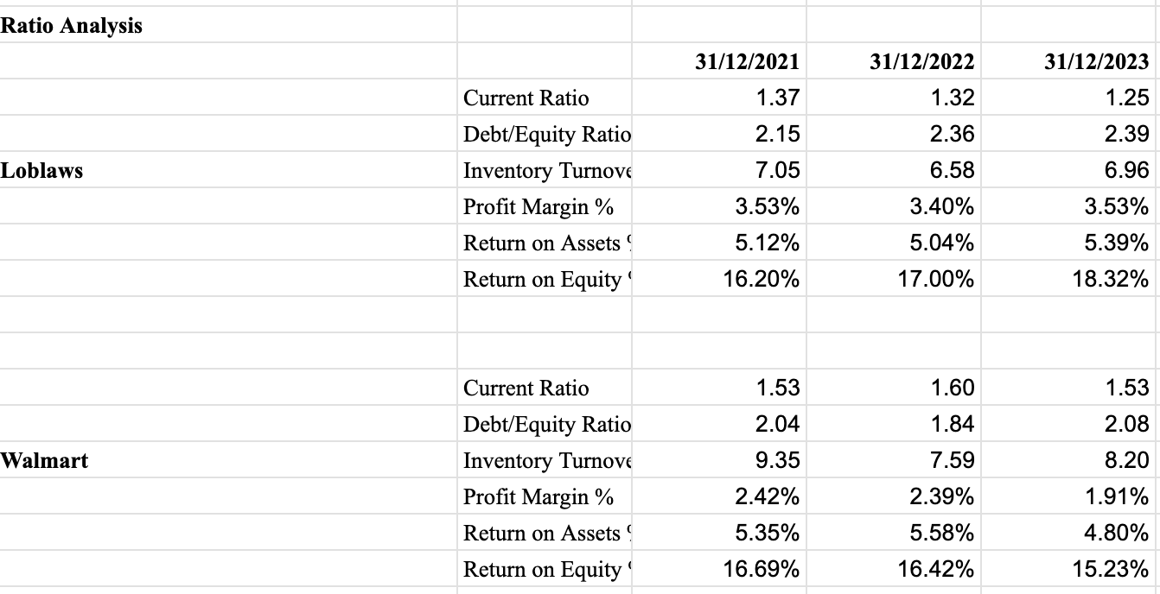
3.2 Common-size Analysis Table
Loblaws Balance Sheet - Common Size
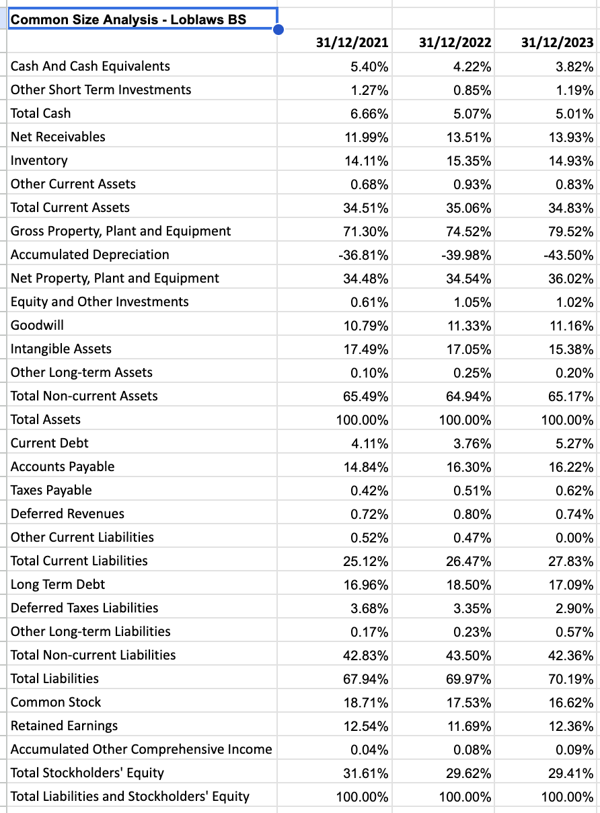
Loblaws Income Statement - Common Size

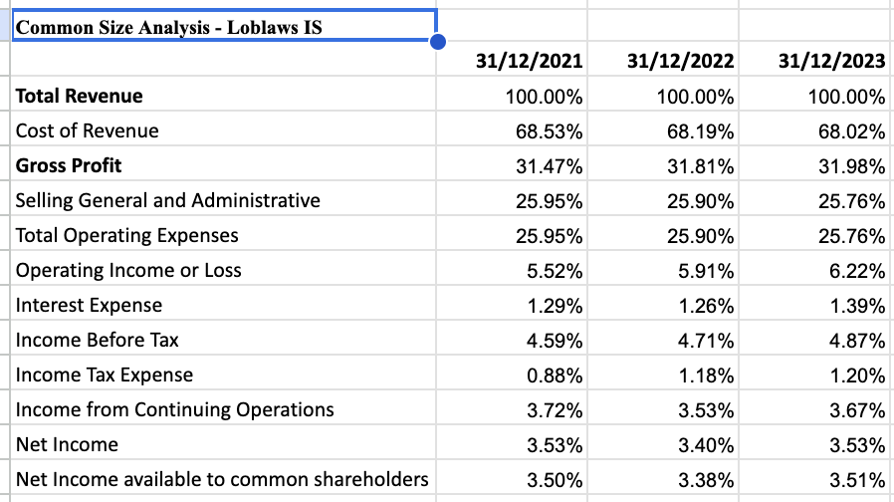
Walmart Balance Sheet - Common Size
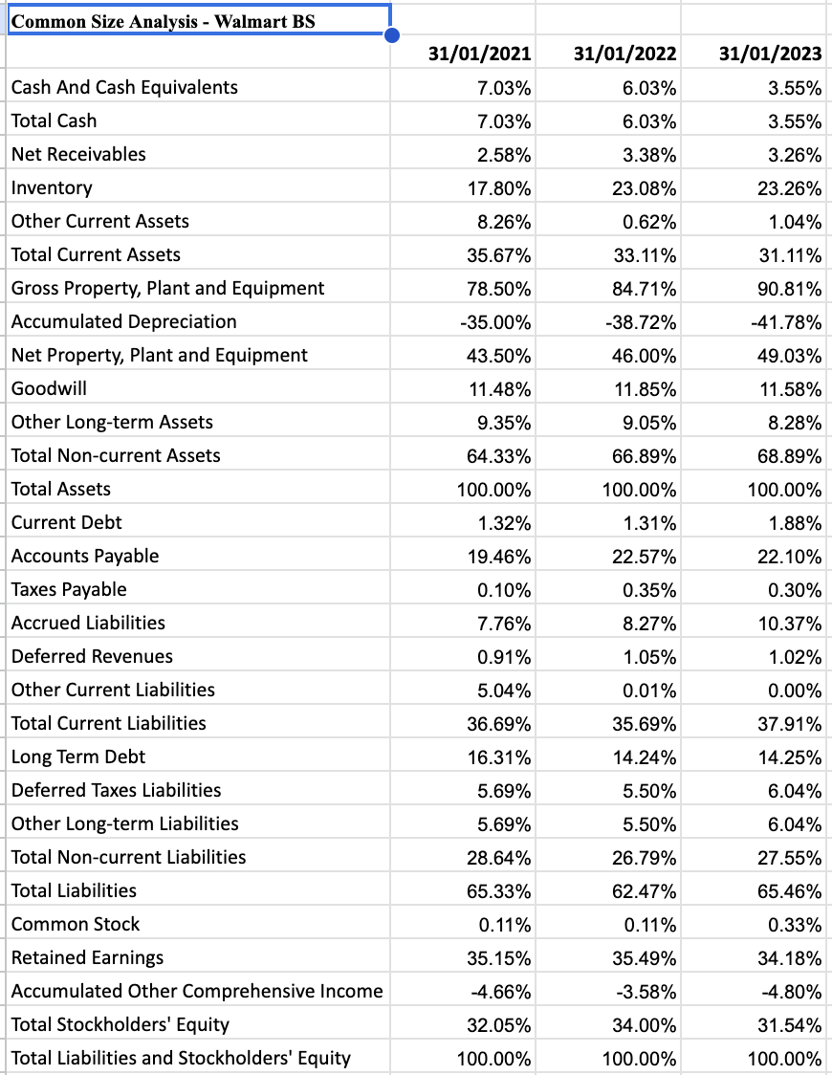
Walmart Income Statement - Common Size
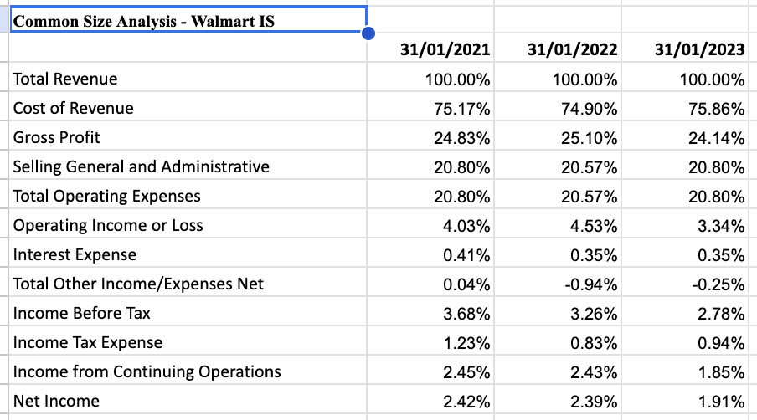
3.3 Pro Forma Income Statement

Pro Forma Assumptions
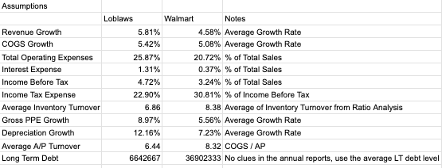

Pro Forma Balance Sheet - Loblaws
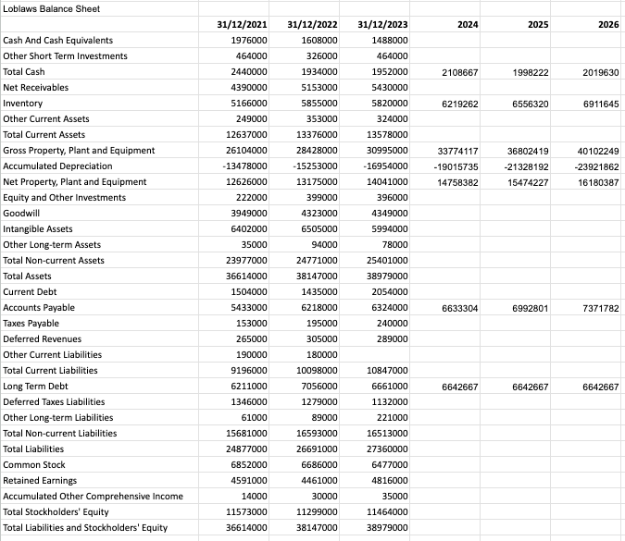
Pro Forma Balance Sheet - Walmart
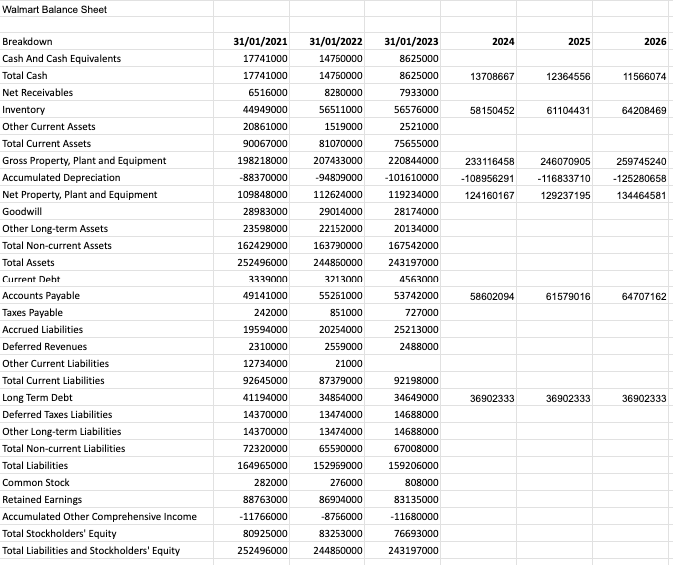
Pro Forma Income Statement - Loblaws
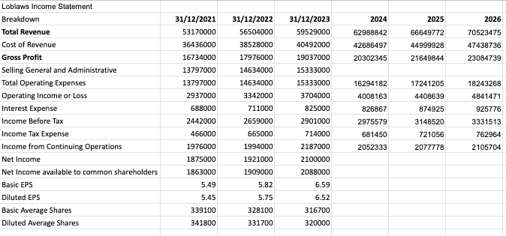
Pro Forma Income Statement - Walmart
- 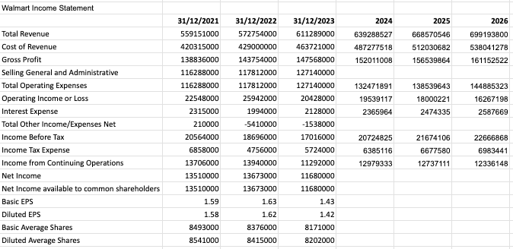
4.1 - Forecasting Stock Value - Loblaws
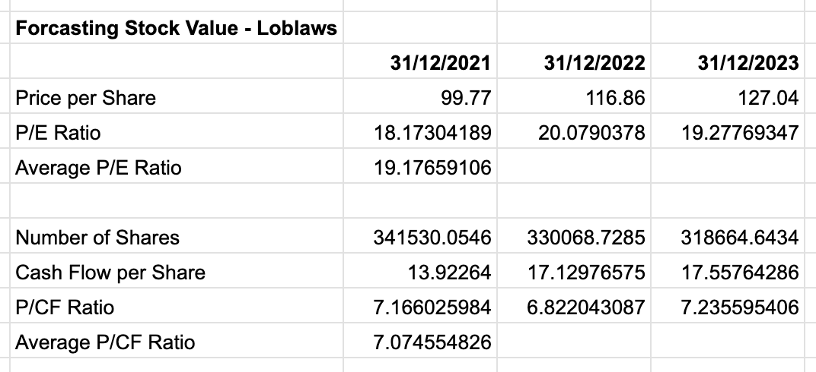
4.2 - Forecasting Stock Value - Walmart
